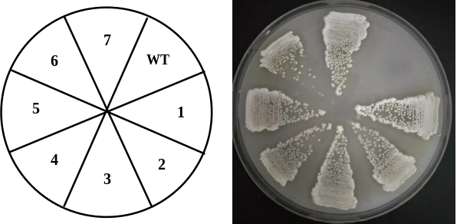

Figure S4. Phenotypic verification of recombinant strains S. rimosus M527-NA_{sr}. Recombinant strains S. rimosus M527-NA_{sr} grew on 2CMC agar medium containing 300 μg/ml apramycin, while control strain S. rimosus M527 did not. 2CMC agar medium was incubated at 28 °C for 4 days.

